**Project Name - Airbag Control System**

**Module number - 2**

**Name - Gurukiran .**

**PS number- 99007901**

## **Requirements**

HRL1 To detect sudden decelerations and send electrical signals to activate an initiator.

* + LLR1 This detection is done using certain sensors called Crash Sensors.
  + LLR2  
    Input port or pin of the controller can be used to do this.

HLR2 To send electric signal inorder to take necessary action that is open the airbags.

* + LLR3 This signal is sent and controlled using certain controller.
  + LLR4 Outport port or pin can be used to do this task

HLR3 To determine the severity of the deceleration that is being caused.

* + LLR5 This is achieved based on the number of sensors that send high.
  + LLR6 Higher the number of sensors sending high signal more severe is the deceleration.

##SWOT ANALYSIS

Strength

* + Airbags are designed to automatically inflate in the event of a sudden deceleration or impact force that would indicate a collision.
  + They decrease the amount of force impacting a person's head by limiting the distance it can fling forward.
  + The priority of this event is very high since in is involving safety feature.

Weakness

* + Microcontroller must provide preference to this event irrespective of the other event since it has higher priority.
  + Any failure of the controller or certain sensors might lead to catastrophe.
  + Must be designed and implemented with atmost expertise.

Oppurtunities

* + Most of the cars implement this feature inorder to ensure the safety of the passengers.
  + It is of greater importance hence uses good quality sensors and cables inorder to ensure there is no failure.

Threats

* + Failure of quality coding might lead to certain danger
  + Validation of the conditions and circuimstances must be done inorder to ensure proper functioning.
  + Various components that are used including the sensors must function properly or else it may lead to danger.

##5W's 1H

What

* + Implementation of airbag conttrol system is to be done.

Why

* + Being one of the most important embedded system in automotive domain it has to be done inorder to ensure safety.

Where

* + This feature is mostly implemented in cars

When

* + During implementation of all the subsystems that are present in automobile.

How

* + Making use of the best controller and quality coding
  + Circuit connections also play a vital role.

Block Diagram

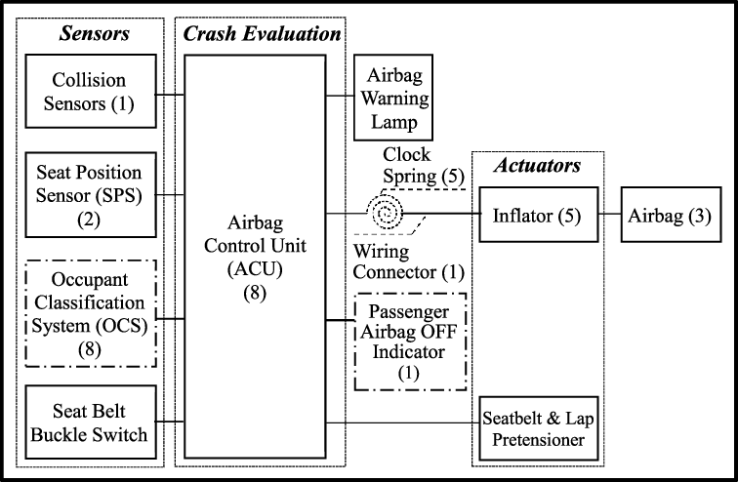

Flowchart

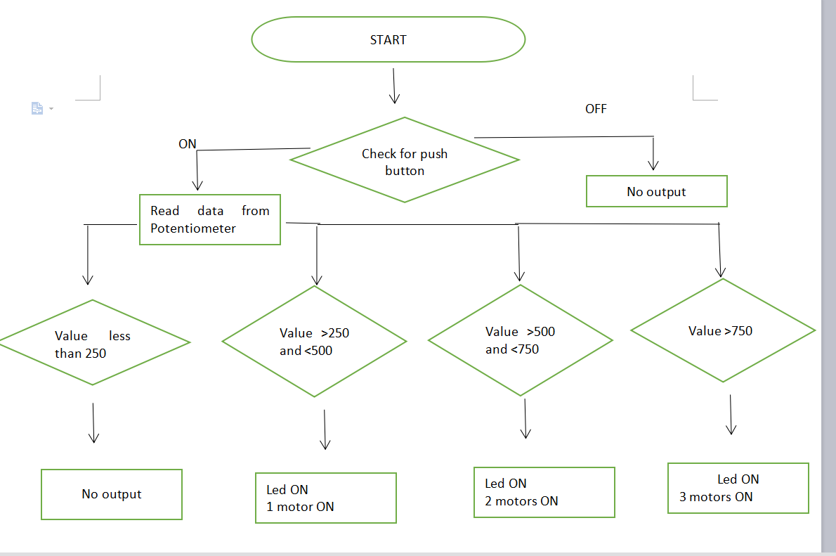

Block Diagram

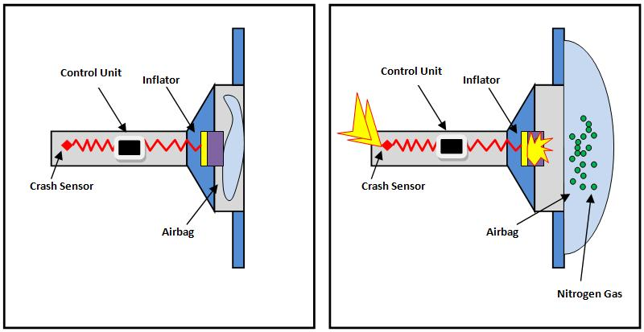

Code

|  |  |  |
| --- | --- | --- |
| #define airbag_indicator 4 //Indicates whether the airbag is turned ON | |  |
|  | #define airbag1 1 //Depicts airbag 1 |  |
|  | #define airbag2 2 //Depicts airbag 2 |  |
|  | #define airbag3 3 //Depicts airbag 3 |  |
|  |  |  |
|  | int analogPin1 =A0; //Crash sensor1 |  |
|  | int analogPin2 =A5; //Crash sensor2 |  |
|  | const char car_on=8; //inorder to indicate that the vehicle is on |  |
|  | bool pressed =false; |  |
|  | int val1=0; //Crash sensor1 input value ,analog in nature |  |
|  | int val2=0; //Crash sensor1 input value ,analog in nature |  |
|  |  |  |
|  |  |  |
|  | void setup() |  |
|  | { //setting up various pins as inputs and outputs |  |
|  | pinMode(analogPin1,INPUT); |  |
|  | pinMode(analogPin2,INPUT); |  |
|  | pinMode(airbag_indicator,OUTPUT); |  |
|  | pinMode(airbag1,OUTPUT); |  |
|  | pinMode(airbag2,OUTPUT); |  |
|  | pinMode(airbag3,OUTPUT); |  |
|  | pinMode(airbag3,OUTPUT); |  |
|  | pinMode(car_on,INPUT_PULLUP); |  |
|  | } |  |
|  |  |  |
|  | void loop() |  |
|  | { |  |
|  | bool car_on_value=digitalRead(car_on); //boolean value used to store the data ,that is whether the vehicle is turned ON or OFF |  |
|  |  |  |
|  | val1=analogRead(analogPin1); //Reading the value from crash sensor1 |  |
|  | val2=analogRead(analogPin2); //Reading the value from crash sensor2 |  |
|  |  |  |
|  |  |  |
|  | if(car_on_value == pressed) //condition that checks whether the vehicle is ON |  |
|  | { |  |
|  |  |  |
|  | if(val1<=250&&val2<=250) //No crash is detected |  |
|  | { |  |
|  | //None of the airbags and also not even the airbag indicator should be turned ON |  |
|  | digitalWrite(airbag_indicator,LOW); |  |
|  | digitalWrite(airbag1,LOW); |  |
|  | digitalWrite(airbag2,LOW); |  |
|  | digitalWrite(airbag3,LOW); |  |
|  | } |  |
|  |  |  |
|  |  |  |
|  |  |  |
|  |  |  |
|  | if(val1>250&&val1<=500&&val2>250&&val2<=500) //Level-1 crash is detected |  |
|  | { |  |
|  | //Airbag 1 and the Airbag indicator must be turned ON |  |
|  | digitalWrite(airbag_indicator,HIGH); |  |
|  | digitalWrite(airbag1,HIGH); |  |
|  | digitalWrite(airbag2,LOW); |  |
|  | digitalWrite(airbag3,LOW); |  |
|  | } |  |
|  |  |  |
|  |  |  |
|  |  |  |
|  |  |  |
|  |  |  |
|  | if(val1>500&&val1<=750&&val2>500&&val2<=750) //Level-2 crash is detected |  |
|  | { |  |
|  | //Airbag 1 and Airbag 2 and also the Airbag indicator must be turned ON |  |
|  | digitalWrite(airbag_indicator,HIGH); |  |
|  | digitalWrite(airbag1,HIGH); |  |
|  | digitalWrite(airbag2,HIGH); |  |
|  | digitalWrite(airbag3,LOW); |  |
|  | } |  |
|  |  |  |
|  |  |  |
|  |  |  |
|  |  |  |
|  | if(val1>750&&val2>750) //Level-3 crash is detected |  |
|  | { |  |
|  | //Airbag 1,Airbag 2,Airbag3 and also theAirbag indicator must be turned ON |  |
|  |  |  |
|  | digitalWrite(airbag_indicator,HIGH); |  |
|  | digitalWrite(airbag1,HIGH); |  |
|  | digitalWrite(airbag2,HIGH); |  |
|  | digitalWrite(airbag3,HIGH); |  |
|  | } |  |
|  | } |  |
|  | } |  |

# **Test plan and output**

| **Test case number** | **Condition** | **Expected Output** | **Actual Output** | **Status** |  |
| --- | --- | --- | --- | --- | --- |
| 1 | Push button is off | Niether LED nor motors | Niether LED nor motors | Implemented |  |
|  |  | should turn ON | should turn ON |  |  |
| ------------------- | ------------------------- | ---------------------------- | -------------------------- | ---------------- |  |
| 2 | Push button is ON potentiometer | Niether LED nor motors | Niether LED nor motors | Implemented |  |
|  | Reads less than 250 | should turn ON | should turn ON |  |  |
| ------------------- | ------------------------- | ---------------------------- | -------------------------- | ---------------- |  |
| 3 | Push button is ON | LED and 1Motor | LED and 1Motor | Implemented |  |
|  | Potentiometers reads more than 250 and less than 500 | should turn ON | should turn ON |  |  |
|  |  |  |  |  |  |
| ------------------- | ------------------------- | ---------------------------- | -------------------------- | ---------------- |  |
| ------------------- | ------------------------- | ---------------------------- | -------------------------- | ---------------- |  |
|  | Push button is ON | LED and 2 motors | LED and 2 motors | Implemented |  |
| 5 | Potentiometer reads |  | should turn ON |  |  |
|  | more than 500 and | should turn ON |  |  |  |
|  | less than 750 |  |  |  |  |
| -------------------- | -------------------------- | --------------------------- | -------------------------- | ---------------- |  |
|  | Push button is ON | LED and 3 motors | LED and 3 motors | Implemented |  |
| 6 | Potentiometer reads |  |  |  |  |
|  | more than 750 and | should turn ON | should turn ON |  |  |
|  | less than 1000 |  |  |  |  |
| ------------------- | -------------------------- | --------------------------- | -------------------------- | ---------------- |  |

# **Images of output**

* * Vehicle is turned off

[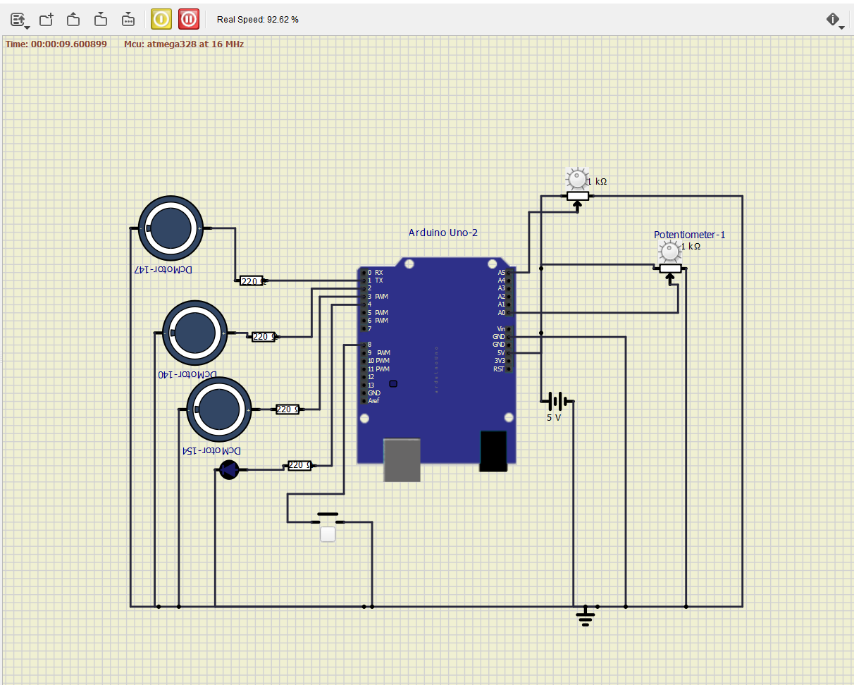](https://user-images.githubusercontent.com/98873064/157160304-d9a069b4-999e-4c6a-b901-2db4eaafed9c.png)

* Vehicle is ON and NO crash is detected

[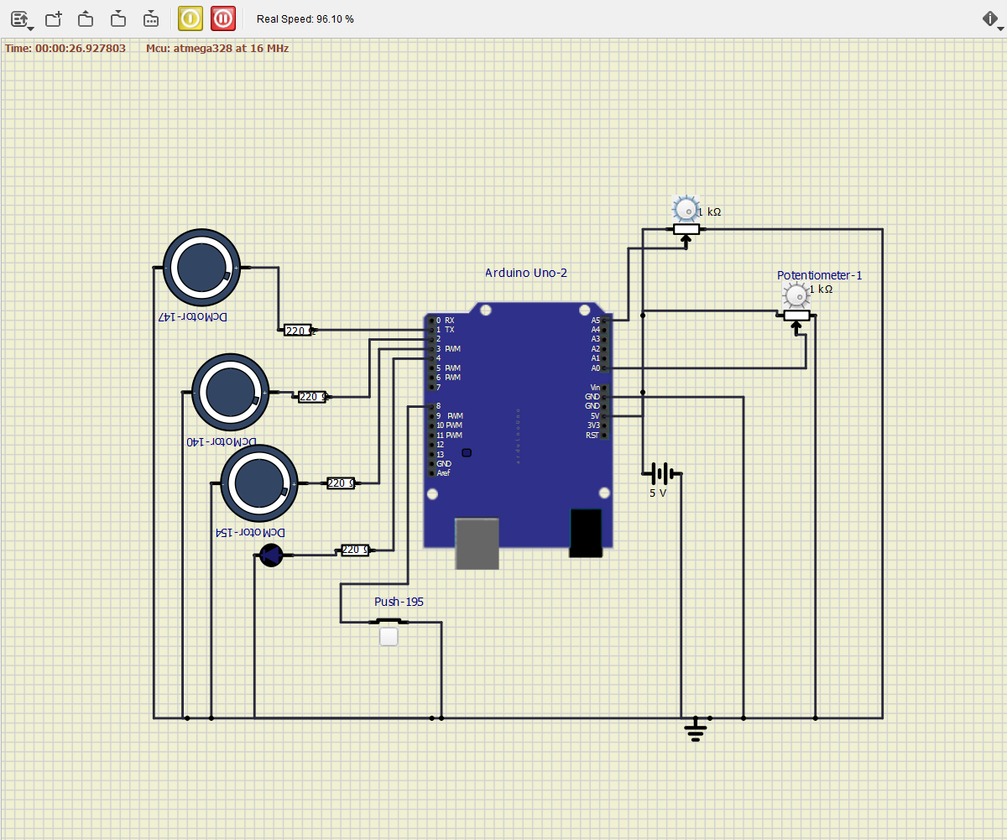](https://user-images.githubusercontent.com/98873064/157161077-5aafc069-b990-4073-a9e7-73c45e6f5ecd.png)

Level 1 Crash is detected

* + Here 1 airbag and LED should turn ON

[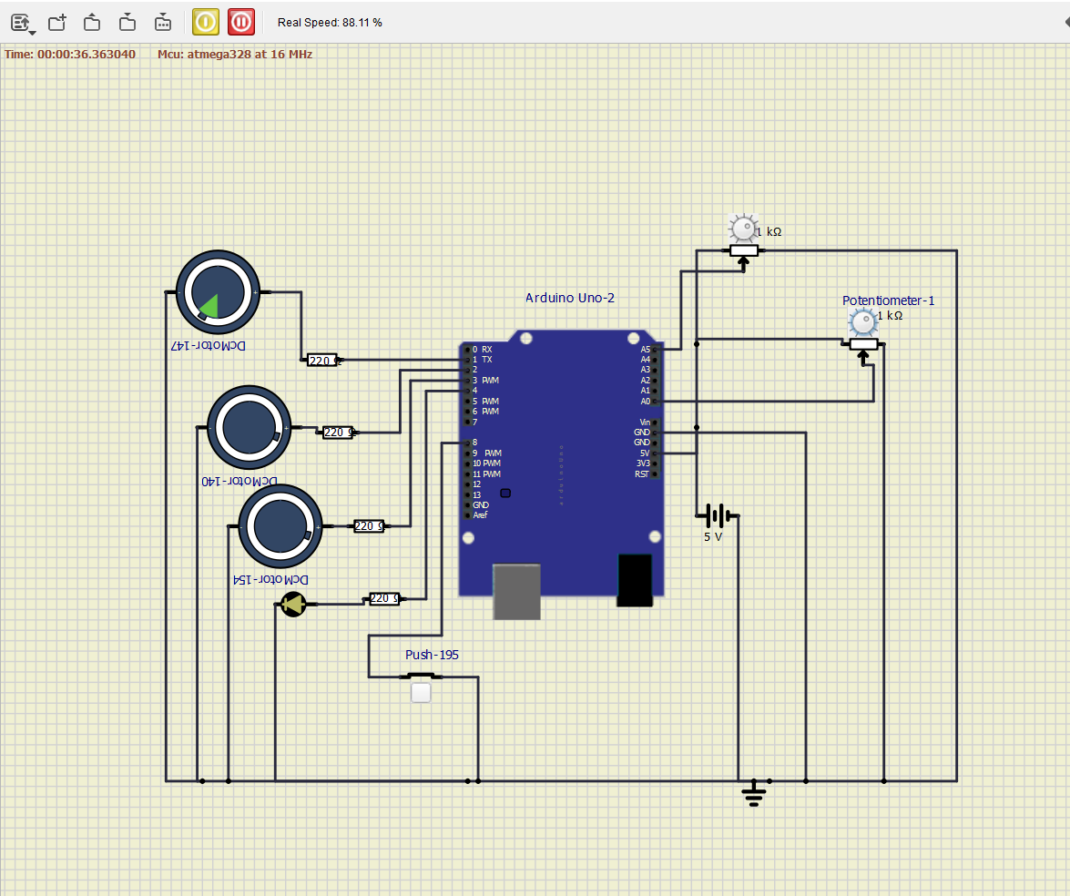](https://user-images.githubusercontent.com/98873064/157160487-b9ac9171-bce9-429a-b8ca-04bf18c73563.png)

Level 2 Crash is detected

* + Here 2 airbags and LED should turn ON

[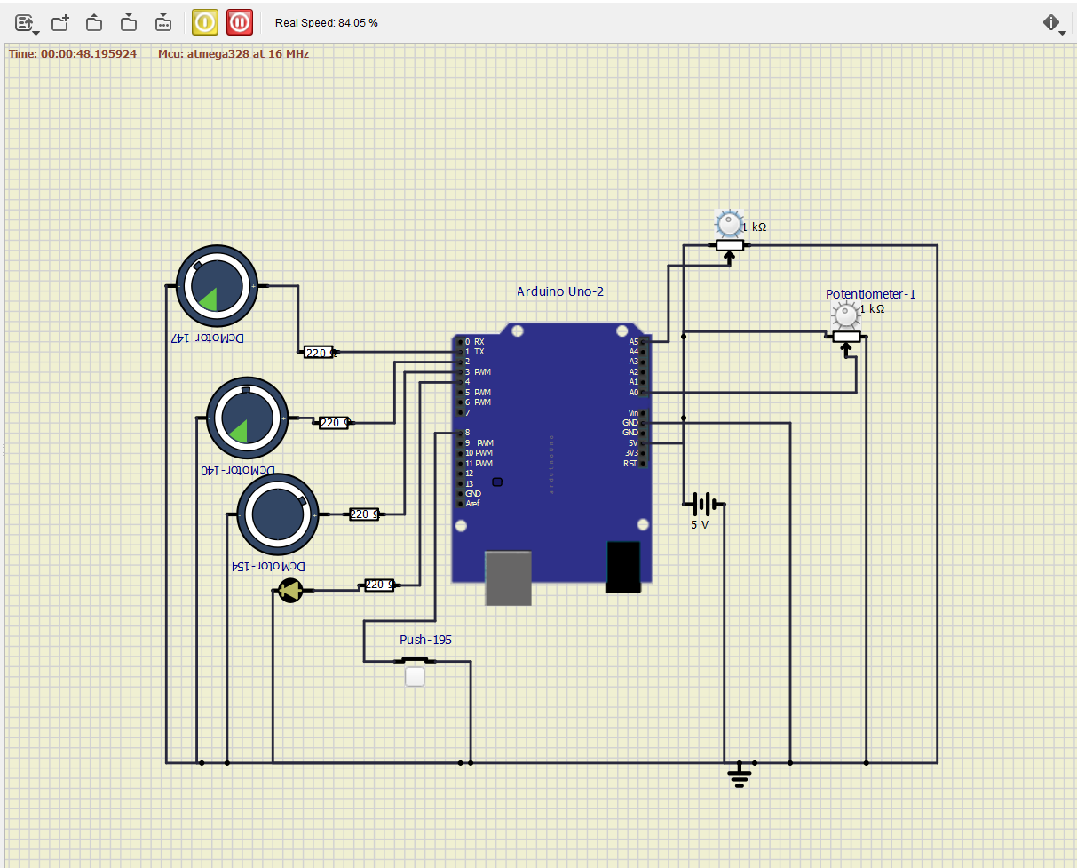](https://user-images.githubusercontent.com/98873064/157160599-8f503825-693c-486d-a0f9-6c7357f6db8a.png)

* Level 3 crash is detected
  + Here 3 airbags and LED should turn ON

[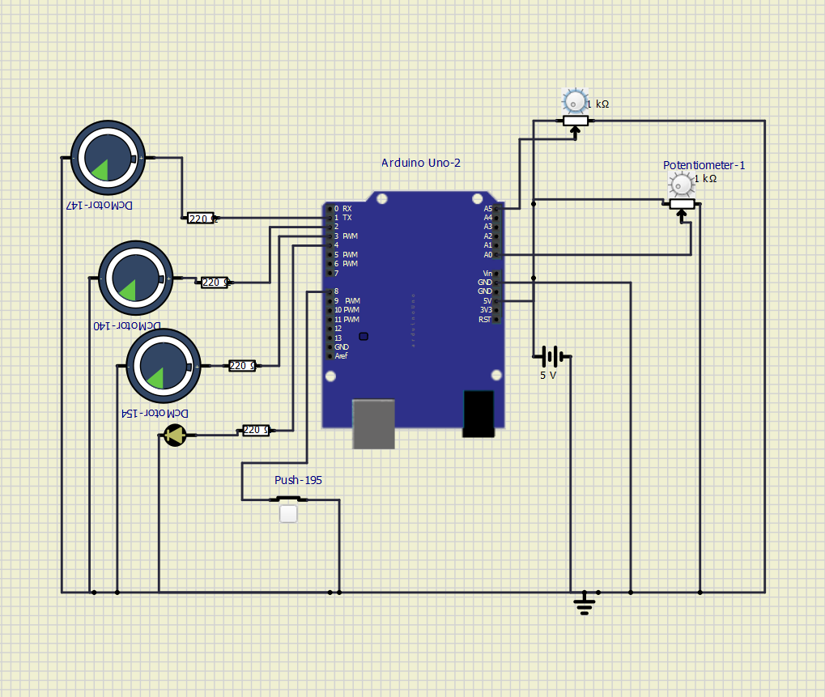](https://user-images.githubusercontent.com/98873064/157160726-9ee53ca4-454a-492b-bbff-1741efc25303.png)